

Early Years SEN Inclusion Service
Specialist Teaching Services

Transition into School/
Between Settings

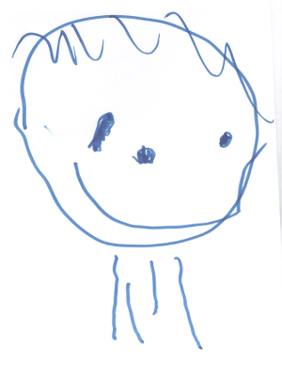

Child’s Name: DOB:

Setting Name:

Address:

Contact No: Key Worker:

Date of entry to setting: Sessions per week:

Other Settings Attended:

Targeted Plan SEND Support Plan EHC Plan

Name of person completing form:  Signature:  Date: | School/Next Setting  Name:  Address:  Tel No: SENCo:
 | Page 1

Child’s Current Development
(This section is optional and you may wish to attach another record of progress that you use already. Please attach Targeted Plan/SEND Support Plan if one exists.)

Personal, social and emotional development | Communication, language and literacy
Mathematical development | Knowledge and understanding of the world
Physical development | Expressive arts ana design

Other issues e.g. personality, preferences, behavioural, medical, dietary etc

Has the child been identified as having Special Educational Needs or Disabilities? If ‘Yes’ please complete page 3 |  | Yes | No
Parent/Carer’s comments:

I agree to this form being passed on to the next setting

Name: Signature: Date:

Page 2

Information for children with identified SEND

Date identified: Targeted Plan

SEND Support Plan

EHC

Nature of concern:
Speech & Language Emotional, Behavioural & Social Other

General Learning Difficulties Social Communication Difficulties

Hearing Vision Medical &/or Physical

ASD pathway ASD diagnosis

Behavioural/Emotional | Communication/Interaction
Cognition and Learning | Sensory/Physical
Other | Medical

General Comments

Parent/Carer comment

Please attach more information on separate sheet if required

Page 3

Information for children with identified SEN
Professional Support

Agencies involved (name and phone number)

Educational Psychologist:  Tel No: | Specialist Teacher (Specify)  Tel No:
Paediatrician:  Tel No: | Speech and Language Therapist:  Tel No:
Health Visitor/Specialist Health Visitor:  Tel No: | Vision Support Teacher:  Tel No:
Occupational Therapist:  Tel No: | Physiotherapist:  Tel No:
Social Worker:  Tel No: | Hearing Support Teacher:  Tel No:
Other:  Tel No: | Other:  Tel No:

Special Adaptations/Equipment used in Current Setting

What | Where | Funded by

Support in Current Setting

What | Who | Why

Page 4

Information for children with identified SEND - Transfer Plan

Special Adaptations (what, who by, funding) | Support needed (what, when)
Equipment (what, where, when) | Staff training (what, who, when, funding)

 |  | Responsible Person |  | Yes |  | Date

School Premises contacted
EHC finalised
Receiving school invited to review
Receiving teacher informed
Building review carried out
Adaptation ordered
Inclusion support arranged
Staffing decided
Advertisement out
Appointment made
Pre-admission meeting (parent, school,
setting, SENCos EY teacher)
First review meeting date set
Home visit by school

EP Educational Psychologist RSHT Receiving School Head Teacher
RSS Receiving School SENCo SS Setting SENCo
AS Area SENCo
Page 5

