Activities

Partnership working across settings and with other professionals is crucial to support effective transition.
Case study
Practitioners at Pelican Playgroup and Weavers Close Primary School embarked upon a joint project to inspire parents to get involved with their children’s learning.

Here Stephanie explains how they worked together to host a mark making workshop for parents and children to enjoy.

After looking at and analysing data, we decided to hold a mark making workshop to boost attainment in children’s writing. Practitioners at the school and pre school worked together to ensure that the parents received consistent messages.

The aim of the workshop was to promote a range of practical activities to support both fine and gross motor skills as the foundation for later writing, in particular exploring different kinds of mark making beyond pencil to paper. These included experimenting with their whole arm and hand to strengthen muscles, as well as using all their senses.

We took into consideration the fact that some of our families lead busy lives, so we decided to hold the workshop in the afternoon for 45 minutes, just before the end of school. Personal invitations were given out to all parents explaining the workshop and what it involved. Family outreach workers and other professionals also attended.

Activities included…
- Gluten free Play dough,
- Drawing in corn flour slime – why not add a dash of peppermint food esscence?
- Sand and glitter mix for mark making,
- Paint the playground with water – you could add a splash of food colouring?
- Making patterns on the table with non toxic paste, adding powder colour to make it interesting
The event was a definite success, with lots of positive feedback from parents. A dad quoted “the interactive afternoon session was a great success. It was a big hit with the children with plenty to do. My daughter loved the glue and glitter activity, in fact so did I! Lots of happy children, mums and dads, well done!”

Some parents enquired about further workshops and as a result of this we are holding an ‘Inspire Maths’ workshop next term. The settings have developed cooking and gardening boxes for children to take home to support the maths workshop.

Showing parents how to use these strategies in their home environment, and seeing parents enjoying getting involved with their child’s learning has been a positive experience for all.

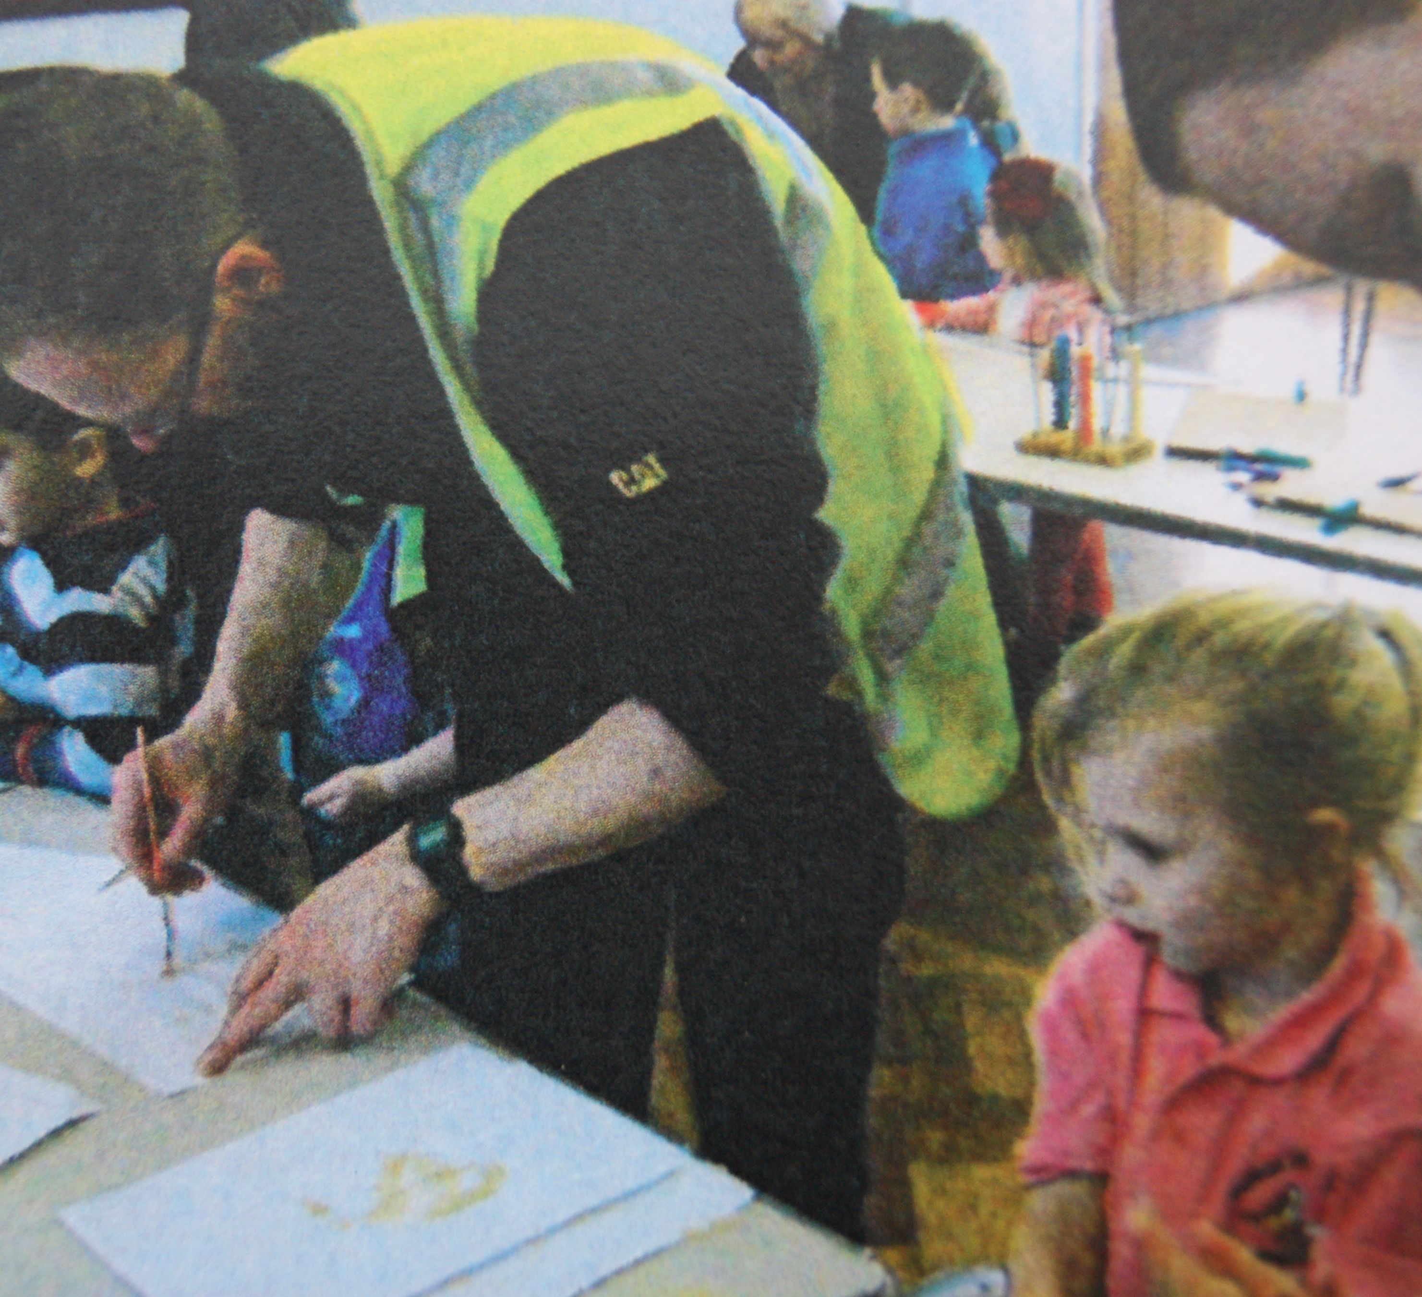

relationships attachment interactions

Key Person role

Developing effective links with children’s centres will allow you to liaise closely with Family Outreach Workers.

As a key person, consider which families might need further support to attend a workshop. How would you encourage vulnerable families to attend?

Further ideas to include in a doodle workshop…
- Creating a 3D sculpture by attaching clothes pegs to a willow trellis?
- Sorting trays with interesting objects and tweezers, for example nuts, bolts, screws, nails, washers…
Don’t forget the importance of large scale activities…
- Sweeping
- Draw shapes in the wind with a wand and dance with a ribbon outdoors
- Action rhymes

Reflecting on practice:

Time to find out… any potential workshop must meet the identified needs of your unique parents.

Have you considered the timing of the session to maximise attendance? How do you find out when your parents are available?

How many different ways could you invite parents? Taking into account their individual needs and preferences.

Remember – painting and drawing with your child is one of the key activities to stretch a child’s mind.
Why not try:
Using chunky chalks outdoors on the pavement on a rainy day
Painting the fence with water on a hot summers day
Think outside the box – drawing doesn’t always have to be on a piece of paper. Have you considered using electronic devices?

Remember… research suggests that practitioners should share with parents the importance of the following:

Be child-led: give opportunity and encouragement to explore with support, encourage child to have some control.
Encouraging and affirming early writing attempts

activities experiences opportunities stimulation
How do you share these key messages with parents?

