Relationships

Parents participating and actively being involved in the early years setting can have a significant impact on improving children’s learning and addressing their needs. This setting discovered an innovative way to build the link between home and setting
Case study
Further to an observation on children playing with the small world the idea for ‘Daisy Town’ began.

Daisy Town was a result of conversations between children and practitioners that later involved the home learning environment.
When observing imaginative play the children were experiencing a little conflict over who was playing with what characters. So…. It was suggested ‘let’s make more people’. At this suggestion the ‘artificial’ characters were discarded and children eagerly began to create ☺
As practitioners worked alongside the children this interactive creative session was buzzing with conversation, excitement, and anticipation. Due to the overwhelming interest raised by the children when creating characters from traditional dolly pegs the interest was sent home. Each child was given a bare peg in a blank envelope. When parents asked practitioners what these were for we explained that we hoped the children would explain on our behalf. Their interpretation of the activity would not only help us to engage with the understanding of the children but would also provide for quality home/setting links. The children certainly didn’t let us down! They all relayed the message well. In fact one parent felt obliged to sign up to Amazon Prime as they needed pegs quicker than nursery could get!!

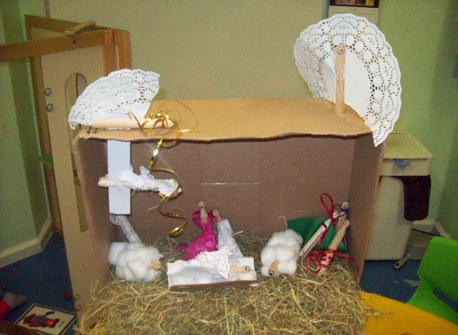

relationships attachment interactions

Key Person role

Key Persons were delighted with the feedback from children and in fact parents. Children were so excited when they returned their fantastic creations to nursery. The children worked alongside parents in making characters of their choice. The children shared these with their friends at nursery during small world play. Observations were also made on children both in isolation and amongst the group.
relat

activities

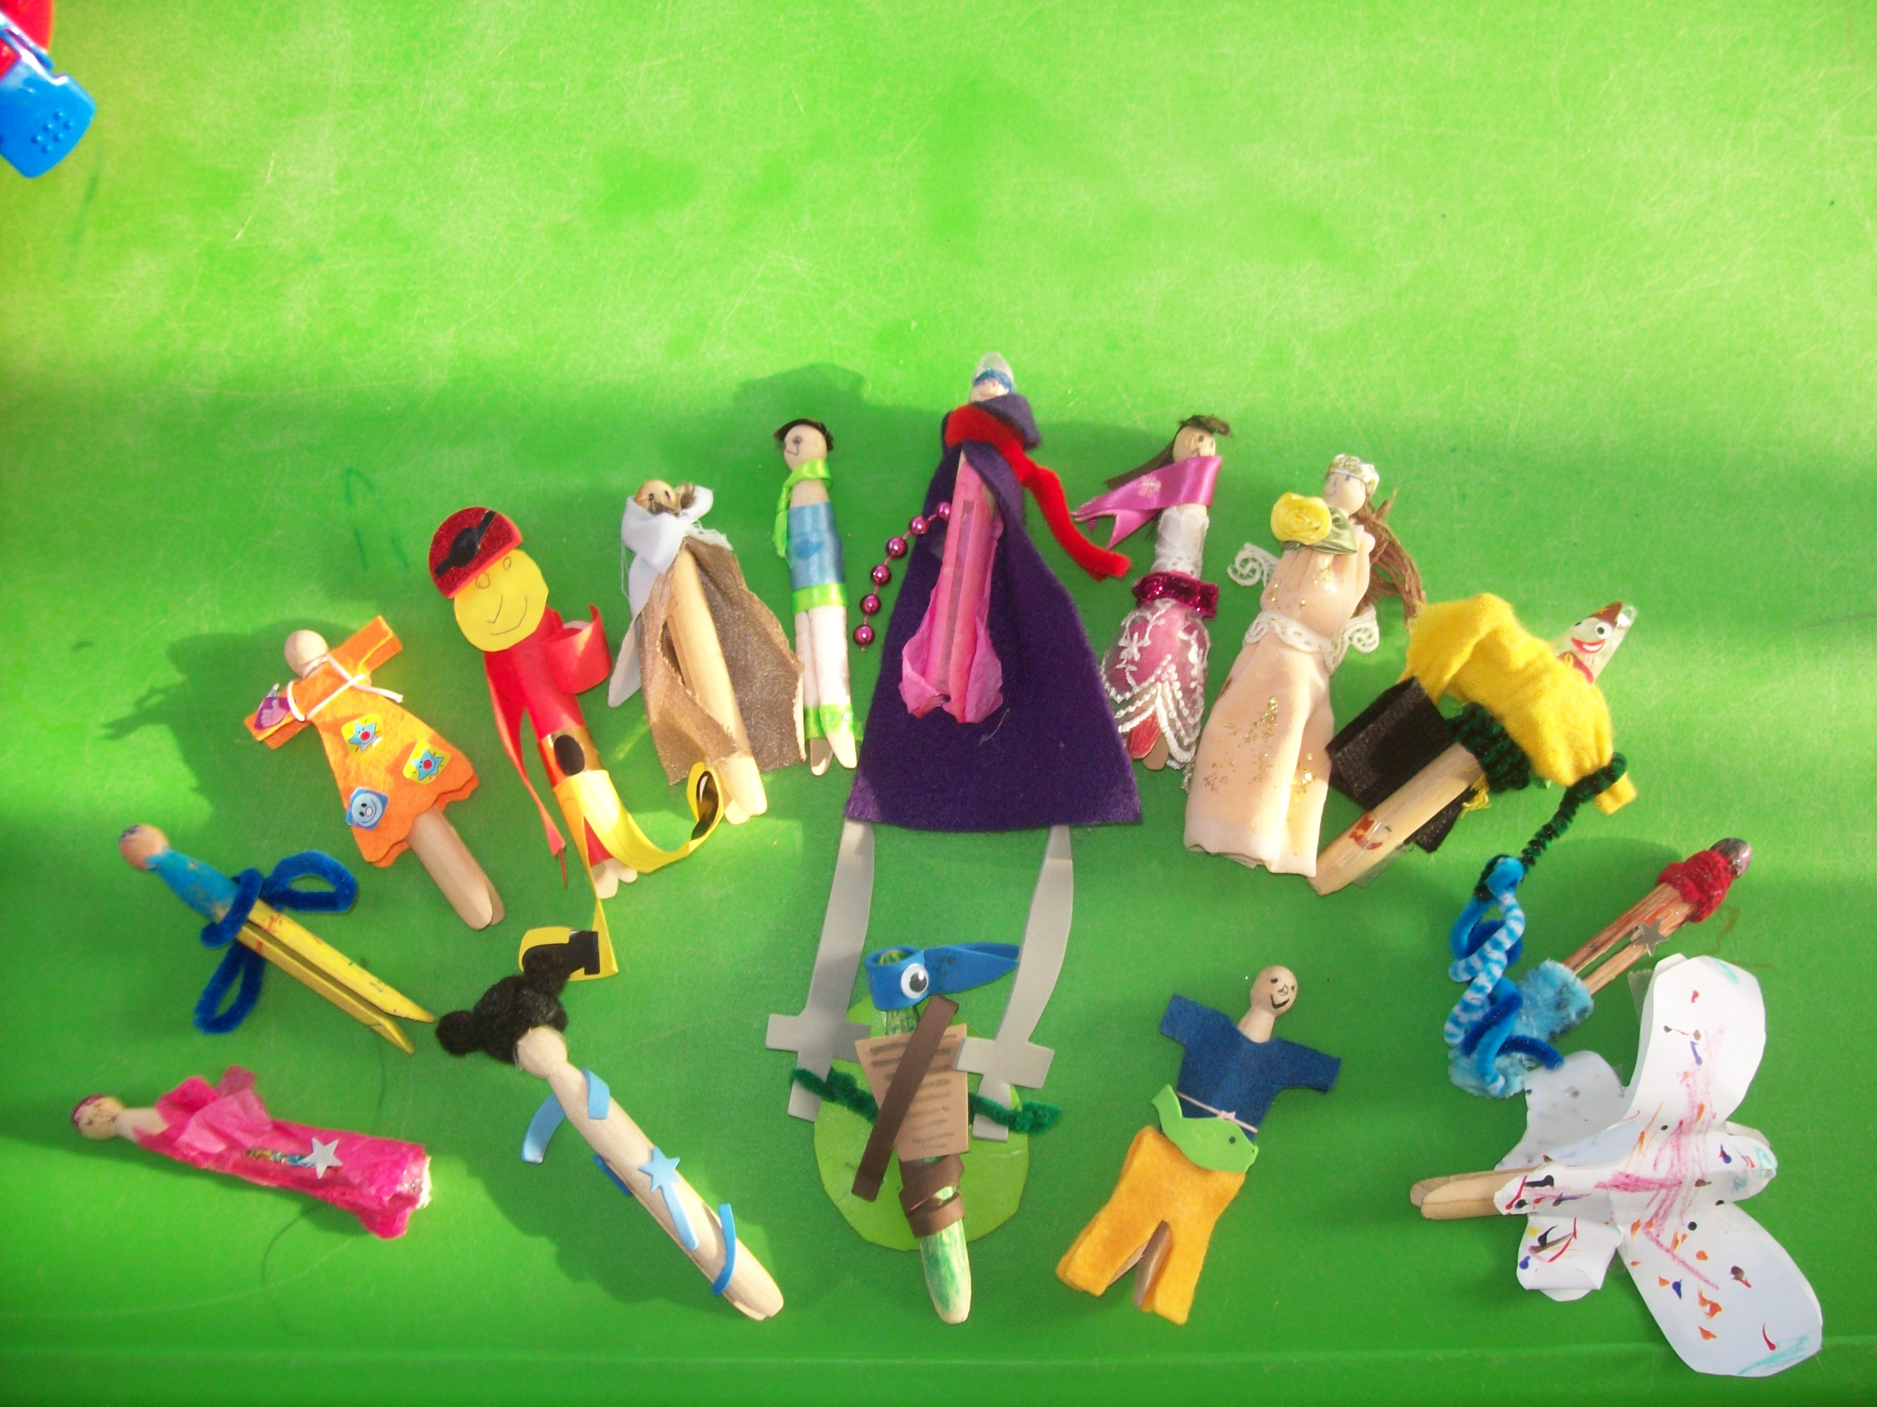
Reflecting on practice:

Such activities link well to the core principles of the Fundamental British Values and provide so many opportunities for future learning experiences.
Children facilitating their own play can be observed as active, participant and capable learners. An interesting reflection again links to the FBV. The children played with these pegs which of course resulted in the pegs looking a little dishevelled! The children repaired and replaced parts to these pegs as they respected that they were made by the children at Daisy Chain.



Remember… research suggests that practitioners should share with parents the importance of the following:

Listening to children; engaging in sustained, shared thinking – reasoning, speculating, describing, making connections and questioning.
Following a child’s interests, encouraging deep involvement.

Recognising success, giving positive feedback – building self-confidence and self-esteem.

activities experiences opportunities stimulation
How do you share these key messages with parents?

