

Hands on… observing young children communicating
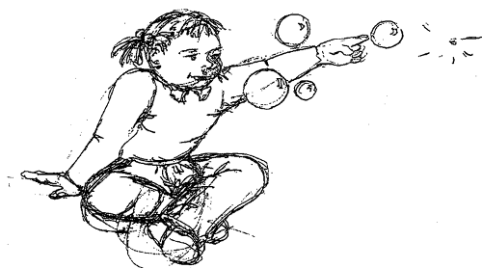
Name
Date of birth
Date started
Name of setting
EARLY COMMUNICATION OBSERVATION PROFILE

The Early Communication Observation Profile
1. Guidance for Use of the Early Communication Observation Profile 4
2. ATTENTION 6
3. SOCIAL INTERACTION 9
4. EXPRESSION 12
5. LISTENING AND RESPONDING 20
6. INTELLIGIBILITY 22
7. DISCUSSION POINTS WITH PARENTS 24

1. Guidance for Use of the Early Communication Observation Profile
The Early Communication Observation Profile is intended to help early years settings to assess the communication / language development of children who they may have concerns about. These concerns will already have been shared with parents.
These children may present as delayed in the development of their receptive (understanding) and expressive language skills in comparison to the majority of children of the same age. They may appear to have difficulties with social interaction, play skills with others and behaviour.
The profile provides a framework for working with parents, sharing and exchanging information about the way their child’s language and communications skills are developing.
The observations look at how, why, when and where the child communicates and their responses to others. They can be carried out as part of the pre-school session over a flexible period of time. It requires no special equipment as it is based mainly on what is happening at the setting and at home. You will need to set time aside for observing the child and for discussions with parents and staff.
The aim is to provide a clearer and more detailed profile of the child’s language and communication development. It will enable practitioners to identify the child’s strengths. It will enable planning for the support of further development in these areas and provide a focus for discussion with parents, colleagues and other agencies involved with the child (Area Senco, Speech and Language Therapist and Educational Psychologist).

The document consists of 6 sections covering the various aspects of communication: -
- Attention
- Social Interaction
- Expression
- Listening and Responding
- Intelligibility
- Discussion points with Parents
Each section asks a variety of questions and provides a space for you to record your observations and evidence. This format will allow practitioners to obtain an individual, personalised snapshot of the child in various situations.
You do not need to use all sections but use your prior knowledge and understanding of the child to select the sections you feel to be relevant.
When the observations have been completed contact your Area SENCO and / or Speech and Language Therapist for support to plan and implement a structured programme to promote early language and communication development.

2. ATTENTION

Getting your attention
How does the child get your attention?
Examples: By crying, tugging at you, vocalising.
Please give some examples you have observed:

Attending to events, objects, other people
How does the child share something interesting with you?
Examples by pointing, looking at you, saying or signing “look”, pulling.
Please give some examples you have observed:

Getting the child’s attention
How do you get the child’s attention?

Examples: by moving close to his/her face, by touching him / her, by saying his / her name.
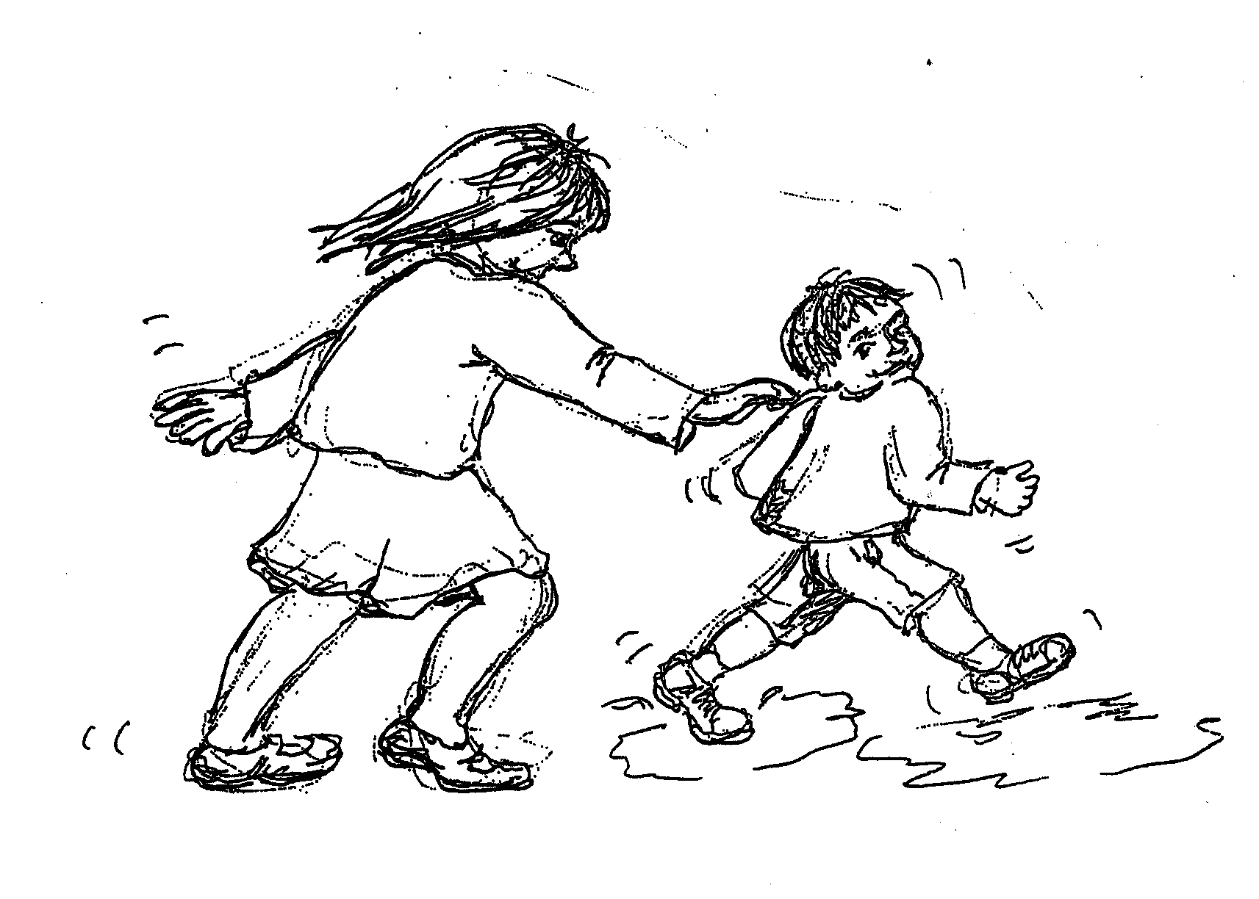
Please give examples:

Following a point
If you point to something you want the child to look at what does she usually do?
Examples: usually does not look, looks if close by, looks if far away.
Please give examples:

3. SOCIAL INTERACTION

Being together
If you are sitting close to the child and communicating with him how does he usually respond?
Examples: unaware that you are talking to him, moves away, shows a little interest, turn his face / body towards you, joins in the conversation using signs, sounds or words.
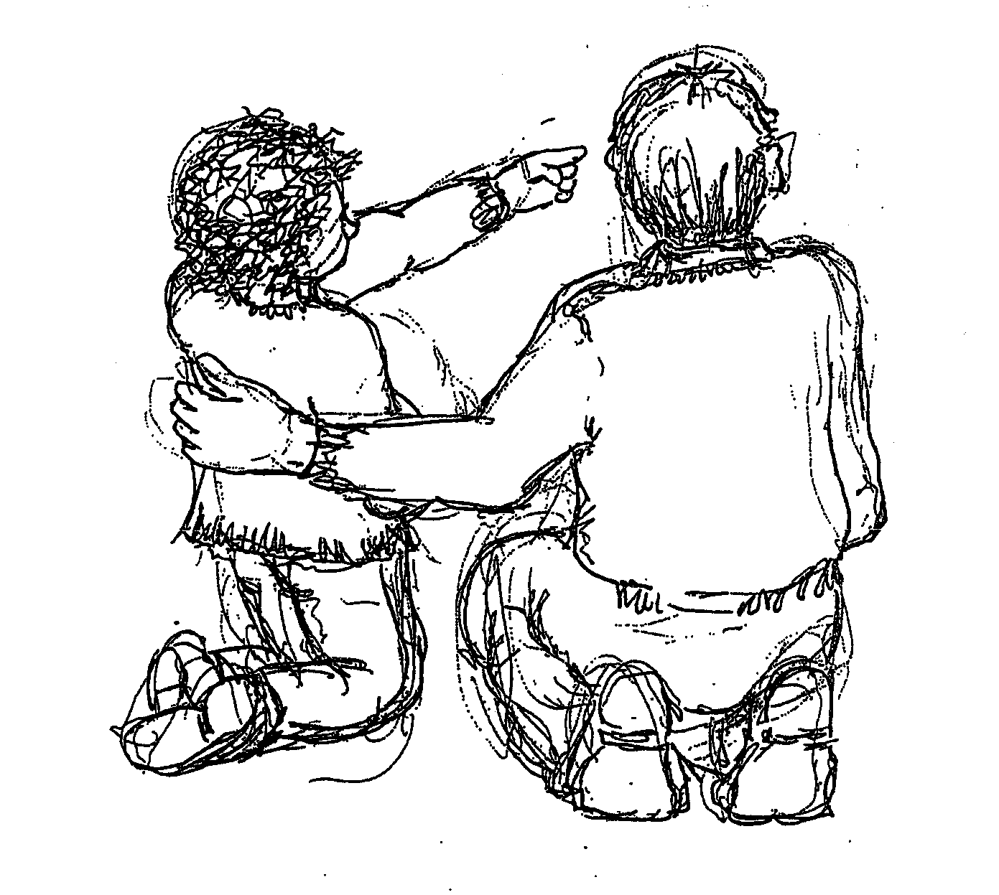
Please give examples from your observations including details of where you were, what was happening and the child’s response.

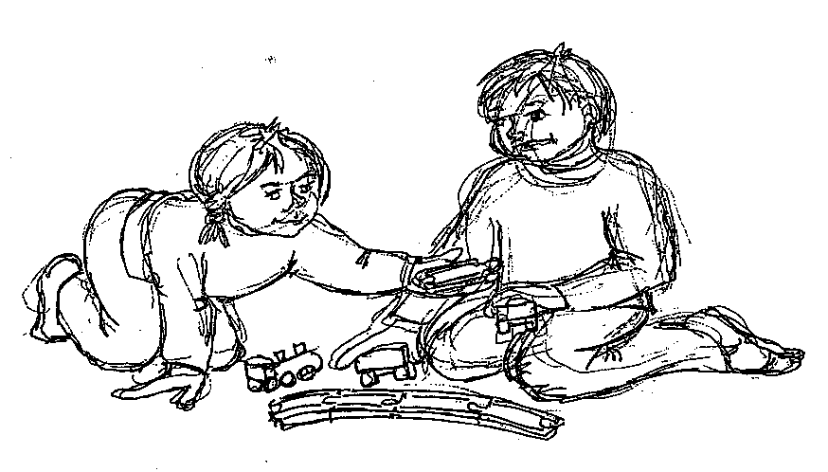
Initiating interaction
How do interactions between you and the child start?
Do you always start the interaction or does the child sometimes start it? If the child sometimes initiates the contact, how does he/she do it?
Examples: by showing you an object, by making eye contact, by vocalising, by signing / speaking to you, by touching you or other gestures, by using your name.
Give some examples of how the child has initiated interaction with you, what were the circumstances, how did they do it?

Maintaining the interaction
How long do interactions with the child usually last?
Examples: one turn each, several turn takes.
Please describe some examples, including who initiated the contact, where and when it took place and the purpose.

Turn taking.
When it’s the child’s turn what does he usually do?
Examples: look or move away, demonstrate interest through body language, make sounds, (what kind of sounds?) uses gesture (describe his actions) signs or speaks in response.
Please give examples from your observations:

4. EXPRESSION

Asking for something
If the child wanted something how would they let you know?
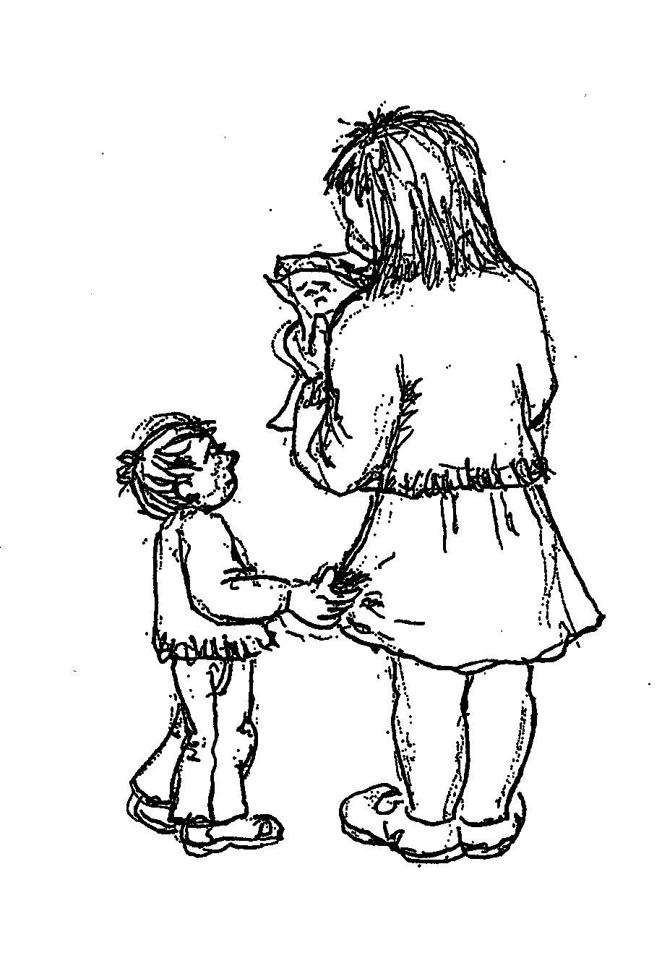
Examples: crying, reaching out or pointing, pulling you and pushing your hands towards it, pointing and naming / signing.
Please give examples from your observations:

Asking for help
If the child needs your help what are they likely to do? (E.g. if the child needs his straps undone to get out of the buggy how would they let you know?)
Examples: crying, holding arms out, making pleading noises, says something like “stuck” or “can’t do it”, calling for you.
Please give examples from your observations:

Asking for more
How does the child let you know that they want you to repeat an action? (E.g. if you are singing a song and they want you to sing it again how would they let you know?
Examples: by making movements, making pleading noises, clapping, saying / signing “more” or “again”.
Please give examples from your observations:

Asking for information
If the child notices something they don’t know about how do they ask you?
By staring at it, pointing and looking up at you, saying “dat” or “whozat”, by asking / signing where, what, why.
Please give examples from your observations:

Expressing pleasure
If the child is enjoying something how would they show it?
Examples: smiling laughing, clapping, saying / signing “I like it” “It’s fun”
Please give examples - who was the adult, what was the situation, describe the child’s response.

Expressing being upset or hurt.
If the child is upset or hurt about something how would they let you know?
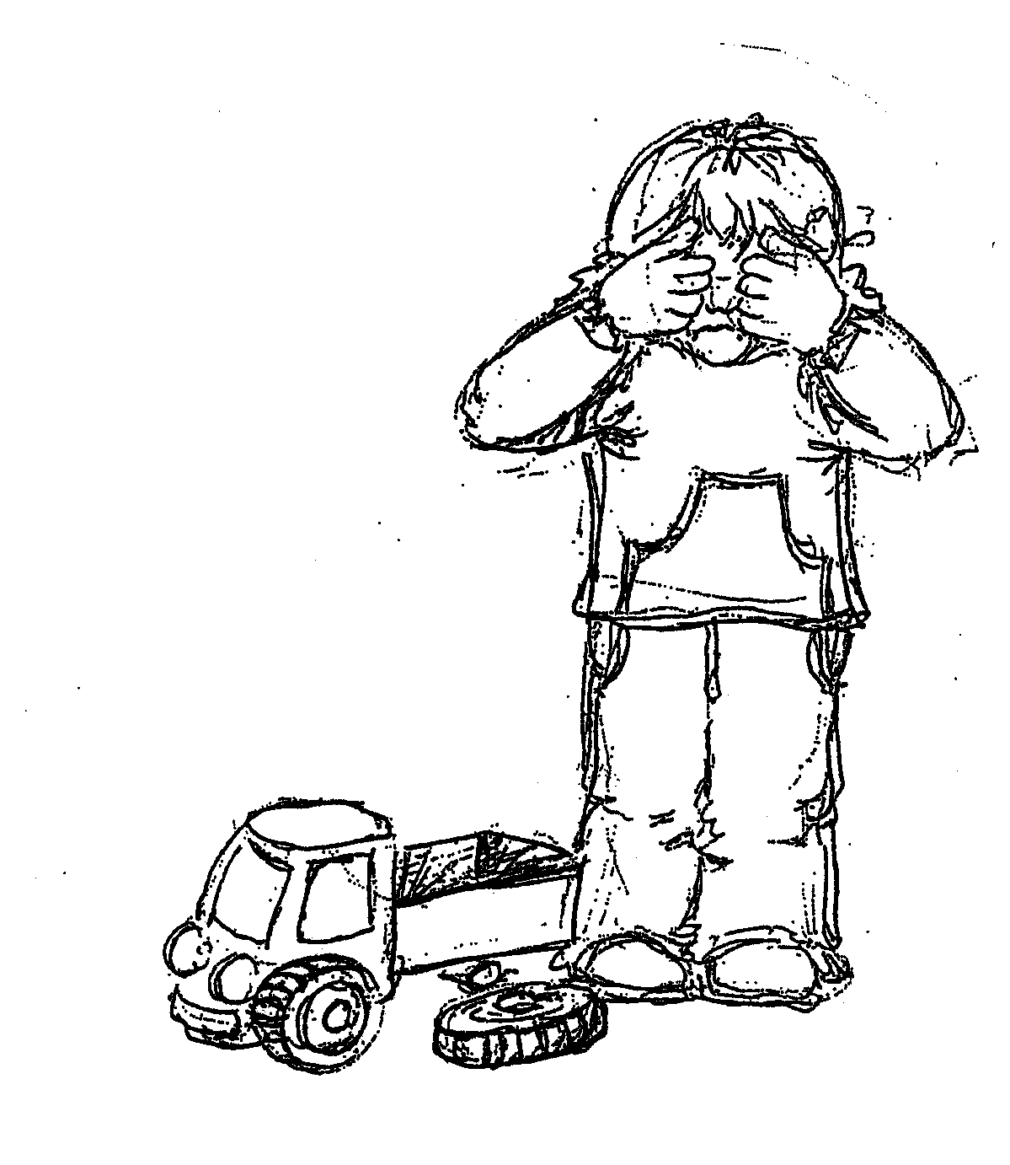
Examples: crying, asking for a cuddle, and telling you where it hurts by pointing, gestures or by explaining what happened.
Please give examples who was the adult, what was the situation, describe the child’s response.

Anticipation
How does the child react to familiar songs and rhymes?
Examples: not interested, responds using body language, e.g. offers hand or tenses, giggles in anticipation of tickling, fills in the last word of a line if you pause, joins in and says or signs it with you, notices if you change part of it.
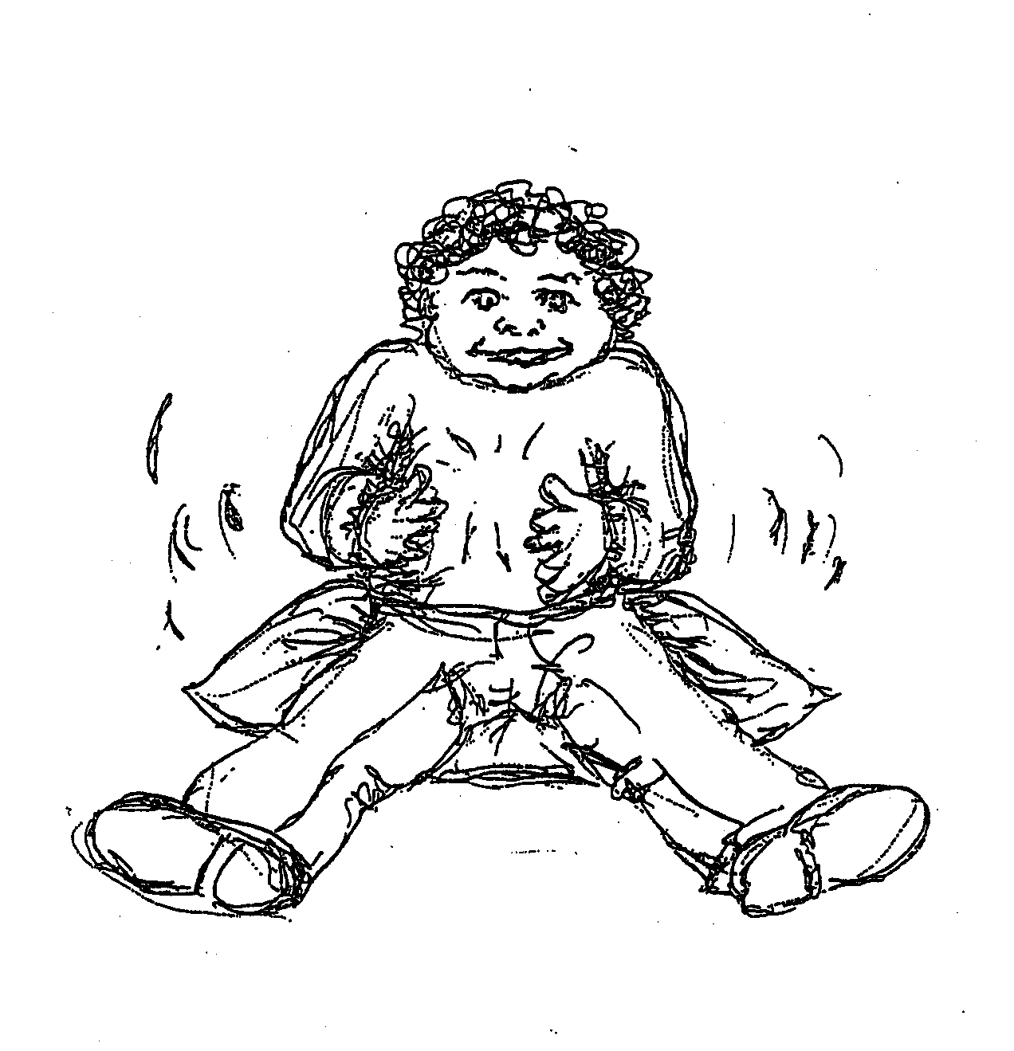
Please give examples:

Amusement
What sorts of things make the child laugh?
Examples: tickling, being swung or chased, funny faces, funny rhymes,
Please give examples:

Response to “no”
If you say “no” or “in a minute” how does he / she usually respond?
Examples: usually accepts it, demonstrates reluctance through facial expression or body language, may tantrum, keeps asking, waits and asks again, negotiates e.g. signs / says ‘later’ or ‘soon.’
Please give examples:
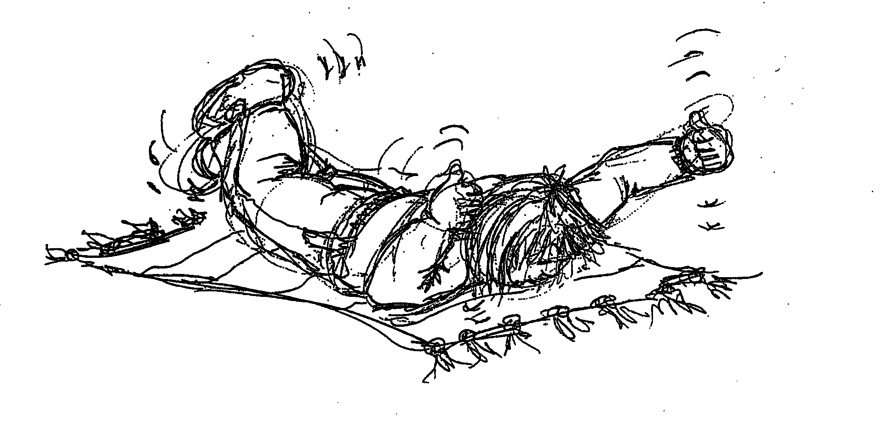

Rejecting
If the child is given something or asked to do something that they do not want how do they respond?
Crying, pushing away or other physical responses, saying / signing “no” or “don’t want it”.
Please describe the situations / circumstances and child’s response.

Greeting - On arrival
How does the child respond on seeing a familiar person?
Takes no notice, smiles and makes a sound in greeting, holds out arms, says / signs greeting words like “hi” or “hello”, says name of person.
Please give examples of who was the adult, what was the situation and the child’s response.

Greeting - On leaving
What does the child do when he or someone is leaving?
Examples: demonstrates reluctance to go, shows no reaction, waves in imitation/ spontaneously, says / signs “bye-bye” (+ name)
Please give examples of who the adult was, what was the situation and the child’s response.

5. LISTENING AND RESPONDING

Listening
When you are speaking to a child how do you know they are listening to you?
Examples: he turns towards you, smiles and nods, says ‘mm’ or some other sound, vocalises / signs in response.
Please give examples:

Responding to speaker
If you give the child a simple instruction “Go and get your coat” how does he usually respond?
Examples: pays no attention, looks at you but doesn’t respond, goes off purposefully but doesn’t come back, responds only if instruction is part of a familiar routine, responds appropriately.
Comments:

Responding to a question
If you ask the child for information, e.g. “where’s your coat?” how is he likely to respond?
Examples: pays no attention, looks at or for his/her coat rather than giving an answer, points, says “there” or “coat gone”, says/sign in the …… or “don’t know”.
Please give examples, including where and what was asked.
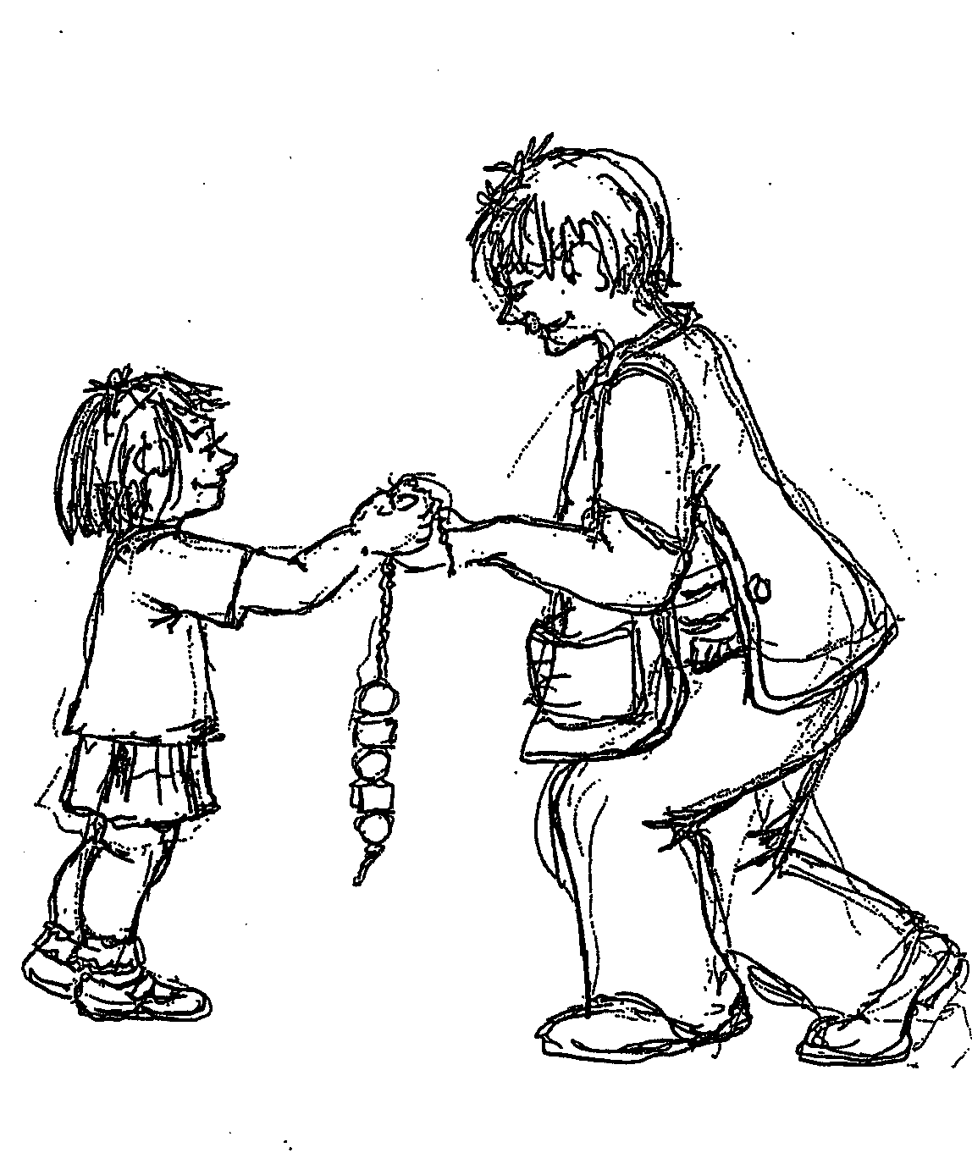

6. INTELLIGIBILITY

Being understood
How well is the child understood by others?
Examples, by parents / carers and by close family.
Please give examples of context, when, where, what was happening. If possible give examples of what the child actually said.

By you.
Please give examples of context, when, where, what was happening. If possible give examples of what the child actually said.

By peers.
Please give examples of context, when, where, what was happening. If possible give examples of what the child actually said.

When not understood
If your child is trying to tell you something and you don’t understand what happens?
Examples; the child gets cross or upset, gives up, may have a tantrum, keeps repeating until you understand, tries telling you a different way, takes you to show you.
Please give examples include the circumstances and the child’s response:

7. DISCUSSION POINTS WITH PARENTS
When your child is playing alone what sorts of sounds does she/he make?
Examples: usually she is very quiet, babbles, uses jargon (sounds like speech but not proper words) makes appropriate noises for toys, e.g. car or animal sounds, talks to self about what he is doing, makes up conversations, uses different voices, invents an imaginary playmates
Comments:
Is your child more willing to communicate with some people than others?
Examples: mother / father, other family members, carers, playgroup staff, family friends, other children, strangers.
Comments:
Where is your child most likely to communicate?
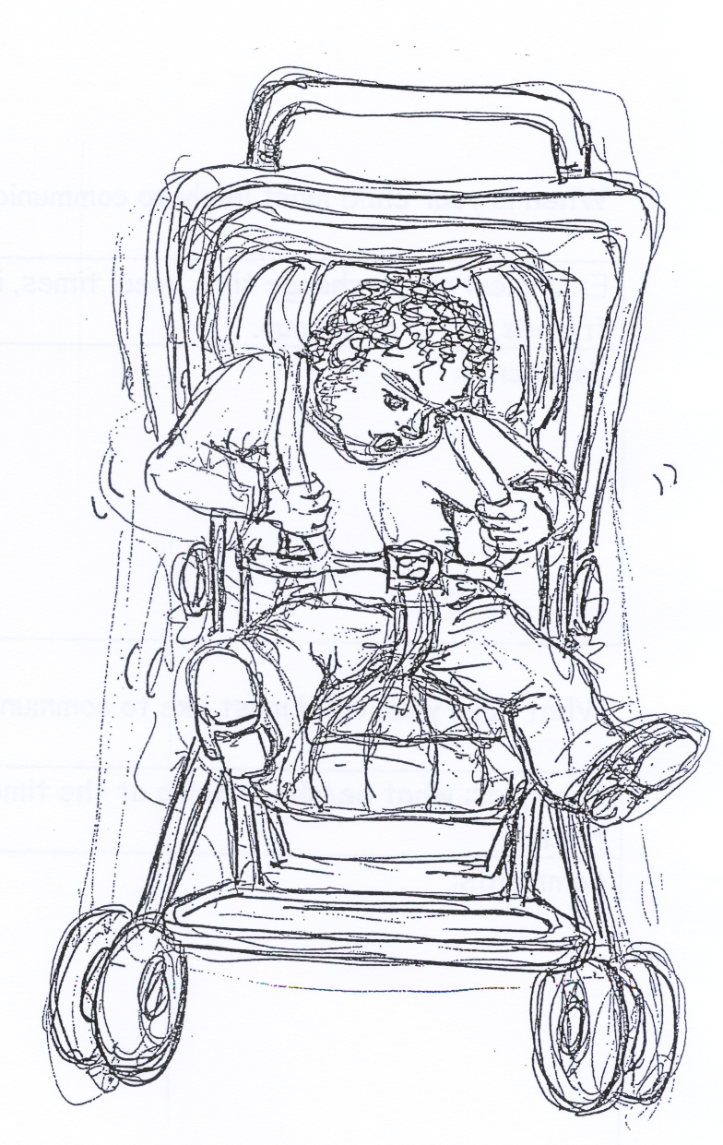
Examples: at home, at nursery, at someone else’s house, out and about, e.g. the park, anywhere.
Comments:

When is your child most likely to communicate?
Examples: nappy change time, meal times, in the bath, in bed, when sharing a book, when playing alone, when playing with friends, after playgroup.
Comments:
What does your child most like to communicate about?
Examples: what he/she is doing at the time, what you are doing, favourite toys, what he/she has seen on television, his/her friends,
Comments:
If your child was playing with other children how would he/she communicate?
Examples: not at all, would play alone, would watch the other children, would communicate through gesture, may grab a toy, would play alongside with no interaction, would play alongside and make occasional comment, would tell other child (ren) what she/he’s doing, would make a suggestion to move the play forward, e.g. ”let’s ….”
Comments:

Something’s happened
How would your child let you know that something has happened you haven’t seen?
Examples: by running to you and crying, by pointing to indicate a bruise or a broken toy, by saying / signing a word for what has happened e.g. “broke”?
Please give examples:

Sharing books
If you are looking at books together what does your child do?
Examples: attends to the book with the adult, follows the adult’s point, shares joint focus, points to a familiar object named by the adult, answers ‘what’s that?’ questions, points to and names things of her/his own accord, talks/signs about what he/she sees happening in the pictures, notices if you leave a bit out, knows some or all the book by heart.
Comments:

