Recycling
Christmas Cards – a starting point:
After Christmas families will probably have lots of Christmas cards they will want to recycle, so why don’t you introduce a recycling centre into your role play area?
Begin by asking the children to bring in their old Christmas cards. Put a selection out on a table and comment with the children about the ones you like and encourage the children to join in.

“l like the card with Santa on it.”
“Look at the snowman!”
“My friend sent me a card with a Christmas tree on it.”

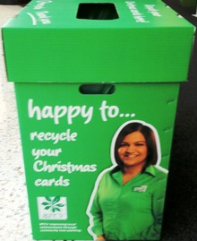

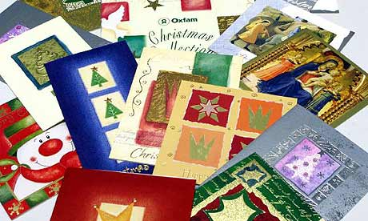
The cards can be sorted, used to deliver in role play - the possibilities are endless.

Recycling
Developing the theme:
Talk with the children about recycling – do they have a recycle bin at home? Show them some of the things that you put in your bin. Suggest that you could have a recycling unit in your area either indoors or outdoors and encourage children to bring things in over the next few weeks.
Once you have a collection of things allow the children to come up with their own ways to sort and classify the objects and to suggest ways to recycle them.
Take the children for a walk to recycle paper, clothes, and batteries in the local community. You could look into recycling bottle tops and used stamps for charities.
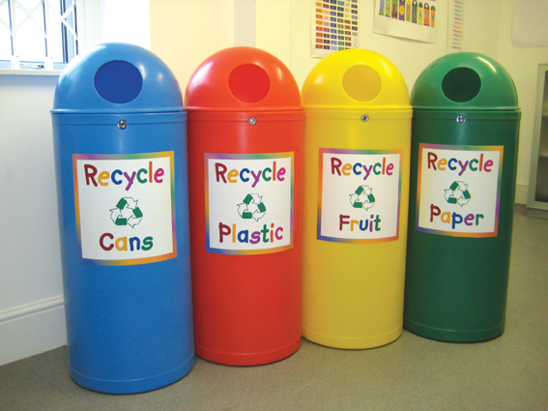

Recycling
Notes for parents/carers:
Talk to your child about some of the things you have thrown away over the course of the day. Can any of them be recycled?
Encourage your child to help you with the recycling this week.
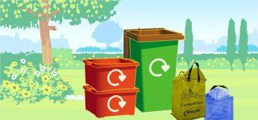

Talk about ‘paper’, ‘plastic’, ‘glass’, ‘metal’ - some of these words may be new to your child so keep saying the words while you are sorting and your child may start to learn them!
Look together to see if you can see the recycling sign on any of your shopping this week.
