Now your child is 2…
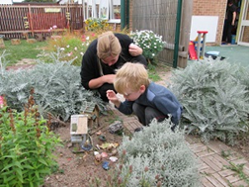
It is time to think about preparing for the next stage in their learning and development.
You will receive a letter from your health visitor when your child is aged between 2 years and 2 years 3 months inviting you to attend an appointment for a health and development assessment. At the appointment you will have the opportunity to discuss your child’s development.
If your child needs extra help this meeting may identify future support that the setting, health visitor or children centre may be able to offer.
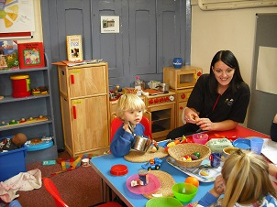
As a parent you know your child best. It is important that everyone who knows your child can contribute to the appointment.
If your child attends an early years setting or child minder your child’s key person will provide you with a short written summary called the Progress check at age 2.


If your child does not yet attend a setting or childminder, but you would like further information then please contact Family Information Service 01163056545 or email family@leics.gov.uk

